# [lightgallery](https://github.com/sachinchoolur/lightGallery)

First of all add lightgallery.css in the <head> of the document.

<head>

<link type="text/css" rel="stylesheet" href="css/lightGallery.css" />

</head>

Then include jQuery and lightgallery.min.js into your document. If you want to include any lightgallery plugin you can include it after lightgallery.min.js. lightGallery and it's plugins are available in lightgallery-all.js

<body>

....

<!-- jQuery version must be >= 1.8.0; -->

<script src="jquery.min.js"></script>

<!-- A jQuery plugin that adds cross-browser mouse wheel support. (Optional) -->

<script src="https://cdnjs.cloudflare.com/ajax/libs/jquery-   
 mousewheel/3.1.13/jquery.mousewheel.min.js"></script>

<script src="js/lightgallery.min.js"></script>

<!-- lightgallery plugins -->

<script src="js/lg-thumbnail.min.js"></script>

<script src="js/lg-fullscreen.min.js"></script>

</body>

#### The markup

lightgallery does not force you to use any kind of markup. you can use whatever markup you want.

<div id="lightgallery">

<a href="img/img1.jpg">

<img src="img/thumb1.jpg" />

</a>

<a href="img/img2.jpg">

<img src="img/thumb2.jpg" />

</a>

...

</div>

#### Call the plugin

Finally you need to initiate the gallery by adding the following code.

<script type="text/javascript">

$(document).ready(function() {

$("#lightgallery").lightGallery();

});

</script>

make sure to include font and img directory in dist/ directory.

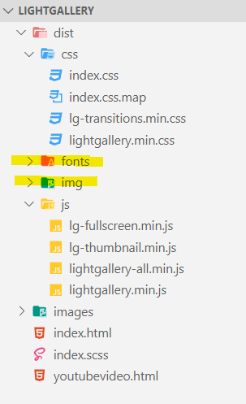

<!-- Overview -->

<!DOCTYPE html>

<html lang="en">

  <head>

    <!-- lightGallery stylesheet -->

    <link rel="stylesheet" href="dist/css/lightgallery.min.css" />

    <!-- lightGallery transition stylesheet -->

    <link rel="stylesheet" href="dist/css/lg-transitions.min.css" />

  </head>

  <body>

    <div id="gallery-row">

      <div class="column">

        <a class="item" href="images/pic01.jpg">

          <img src="images/pic01.jpg" />

        </a>

...

      </div>

...

    </div>

    <!-- jQuery CDN -->

    <script

      src="https://code.jquery.com/jquery-3.4.1.js"

      integrity="sha256-WpOohJOqMqqyKL9FccASB9O0KwACQJpFTUBLTYOVvVU="

      crossorigin="anonymous"

    ></script>

    <!-- A jQuery plugin that adds cross-browser mouse wheel support. (Optional) -->

<script src="https://cdnjs.cloudflare.com/ajax/libs/jquery-mousewheel/3.1.13/jquery.mousewheel.min.js"></script>

    <script src="dist/js/lightgallery.min.js"></script>

    <script src="dist/js/lightgallery-all.min.js"></script>

    <!-- lightgallery plugins -->

    <script src="js/lg-fullscreen.min.js"></script>

    <script src="js/lg-thumbnail.min.js"></script>

    <script>

      $(document).ready(function() {

        $("#gallery-row").lightGallery({

          selector: ".item", <!-- selected gallery elements ‘.item’ class -->

          mode: "lg-tube" <!-- [transition effect](https://sachinchoolur.github.io/lightGallery/demos/transitions.html)-->

        });

      });

    </script>

  </body>

</html>